**Assignment:** SFM-1-Assignment

**Note:** If there are multiple files for the assignment, please zip all the files in .zip format.

**Submitted By:**

**INSTRUCTIONS**:

1. Use the MS Excel File “XL_FILE_ SFM-01_AssignmentData” to complete this assignment. Refer to relevant sheets within this Excel file to answer the respective questions given here.

2. Upload the updated MS Excel File and this word file to submit your work.

3. **Note: If there is more than one file kindly zip it in .zip format.**

**HINT:** Please refer to “In_Class_file”, “XLP”and lecture recording to do this assignment.

**(Each Question carries 5 marks)**

**Question 1:**

A) Open the Question1 worksheet in the “XL_FILE_SFM-01_AssignmentData" and fill different colors to open high and closing price.

Please remember the data should be visible after the color filling.

B) In the class we created a separate column that mentions whether the price increased or decreased from the previous day. Repeat that exercise and create a separate column. We all know that an up movement in the market is denoted by green signal and the down movement by red signal. Assign green color to “Increase” and red to “Decrease”. Choose closing price for this calculation. Please document your steps.

C) Plot the open price, high price and the closing price on the same graph.

**Answer 1:**

A🡪Filled different colors to OPEN, HIGH & CLOSE prices.

B🡪Created column to Label today’s closing price increased or decreased from the previous day.

Formula used🡪 **=IF(E3>E2,"INCREASE","DECREASE")** {here **E** represents closing prices}

And assigned respective colors to **Label** column using **New Formatting Rule.**

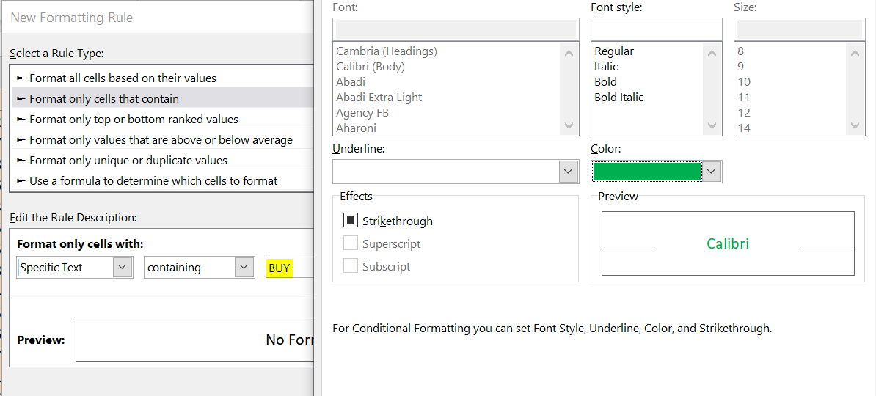

**Result:**

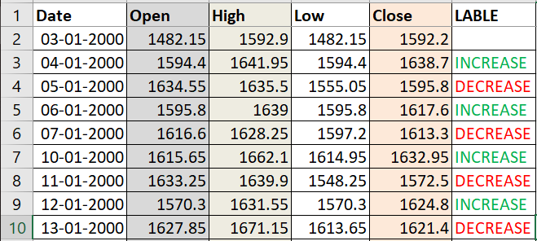

**C🡪Chart**

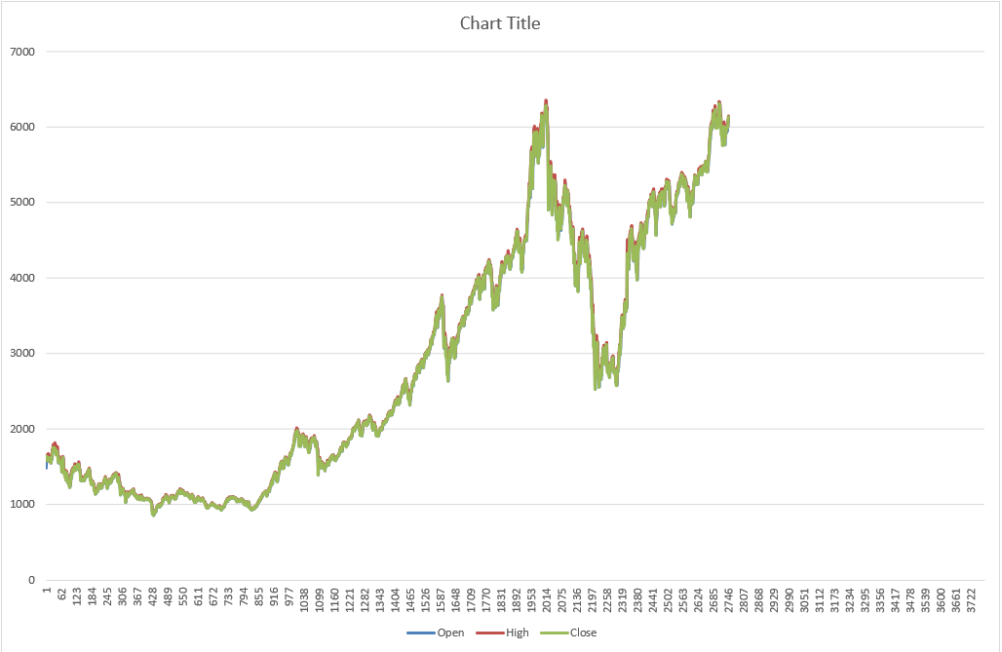

**Question 2:**

Taking reference from “XLP.xlsm” file (where signals are toggled between “BUY” and “SELL”), please try to create another model (using the data available in “Question 2” worksheet in “XL_FILE_SFM-01_AssignmentData") with the following conditions:

A) If today's close price is greater than maximum of previous 5 day closing price then buy  
  
B) If today's close price is less than minimum of previous 5 day closing price then sell  
  
C) There may be consecutive buy and sell signal. Create a column called rule that has alternate buy and sell signals only (Since, we are working on toggle system, once the BUY /SELL is encountered, the system should wait till next SELL/BUY comes as per the condition defined in A. You’d be exiting the trade when the opposite signal comes. This also means that you’ll have one open position at all times after the first trade.)

**Answer 2:**

A🡪Created a column to calculate **maximum price of previous 5 day closing price** for each day using below formula. And created **Signal** column to mark the “BUY” signal if today's close price is greater than maximum of previous 5.

Formula🡪 =**MAX (E2:E6)** {here **E** represents closing prices}

B🡪Created a column to calculate **minimum price of previous 5** **day closing price** for each day using below formula. And created **Signal** column to mark the “SELL” signal if today's close price is less than minimum of previous 5.

Formula🡪 **=MIN (E2:E6)** {here **E** represents closing prices}

C🡪Created a column called **RULE** that has alternate buy and sell signals. Removed consecutive buy and sell signal with help of **Trade** and **Inventory** columns.

Formula used for Trade🡪 =**IF (AND (H7="SELL", J6<>-1), -1, IF (AND (H7="BUY", J6<>1),1,0))** {here **H** represents consecutive buy and sell signal and **J** Inventory/position size}

🡪Please find strategy **summary**:

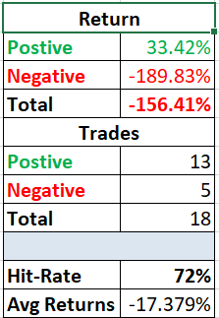

**Question 3:**

Data for a stock price dated from 1-Jan-2010 to 18-Jan- 2017 is given to you (using the data available in “Question 3” worksheet in “XL_FILE_SFM-01_AssignmentData"). Now, calculate VWAP for the same. An example of the VWAP calculations has been done in the sheet XL_FILE_ SFM-01_ In_Class_file.xlsm

**Answer 3:**

🡪Please find formula for **VWAP:**

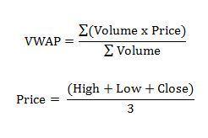

🡪Given below data:



🡪Created below columns:



🡪Please find below formulas used for creating above mentioned columns.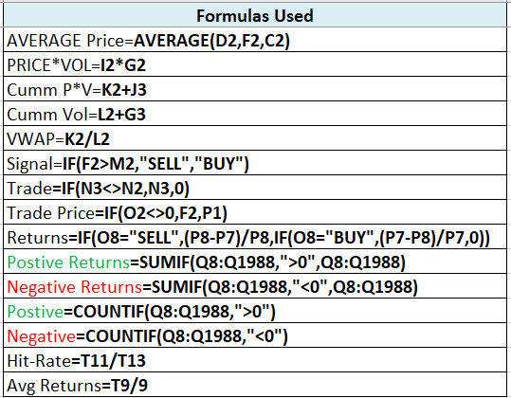

🡪Please find strategy **summary**:

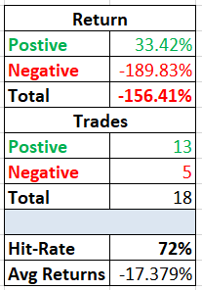

🡪**VWAP** **Chart**

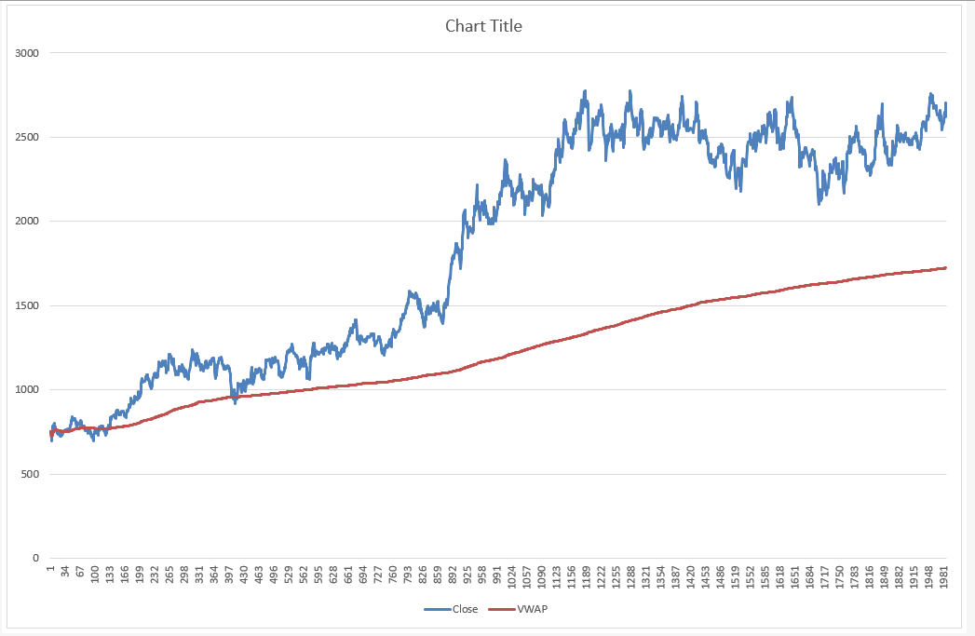

**Note:** VWAP strategy🡪 “BUY” when closing price below VWAP and “SELL” when closing price above VWAP.

**Question 4:**

For the Infosys data from the previous question, calculate RSI (Relative Strength Indicator). The steps are explained in the slides and an example has been done in the spreadsheet used in the class: XL_FILE_ SFM-01_AssignmentData (“Question 4” worksheet). What do you infer? Does the RSI indicate overbought and oversold shares? Please document and submit your assumptions (if any) with the assignment.

**Answer 4:**

🡪Please find formula for **RSI:**

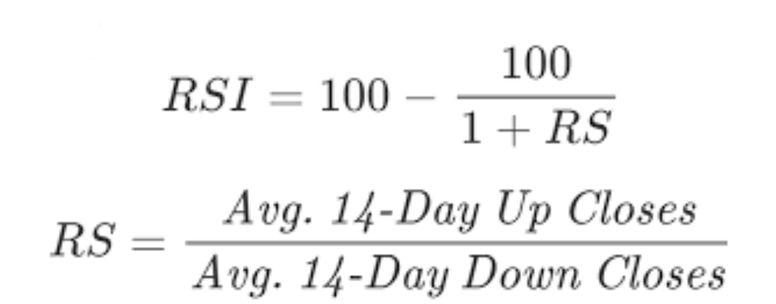

🡪Given below data:



🡪Created below columns:



🡪Please find below formulas used for creating above mentioned columns. 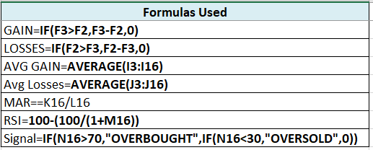

🡪RSI Chart: 70<RSI 🡪 overbought & 30>RSI 🡪 oversold.

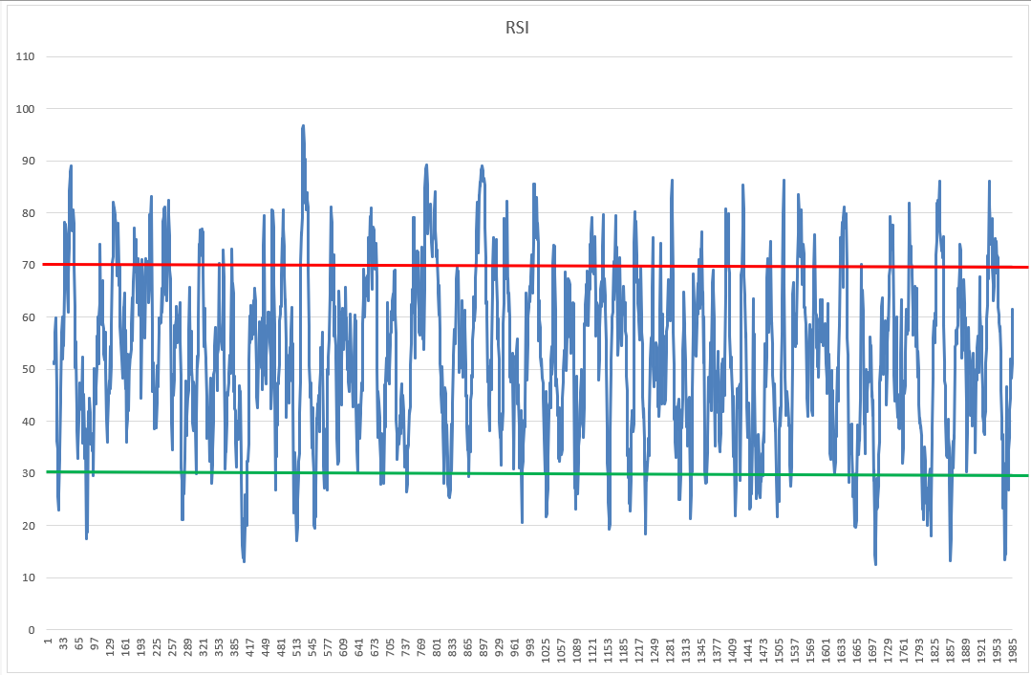

**Note:**

RSI are that values of 70 or above indicating that a security is becoming overbought or overvalued and may be primed for a trend reversal. An RSI reading of 30 or below indicates an oversold or undervalued condition.

**Important points to keep in mind while attempting the assignment questions:**

Try figuring out the summary of your strategy wherever possible and you can include below points to summarize your strategy:

* Positive Returns, Negative Returns, Total Returns
* Positive Trades, Negative Trades
* Hit Ratio, Average Returns